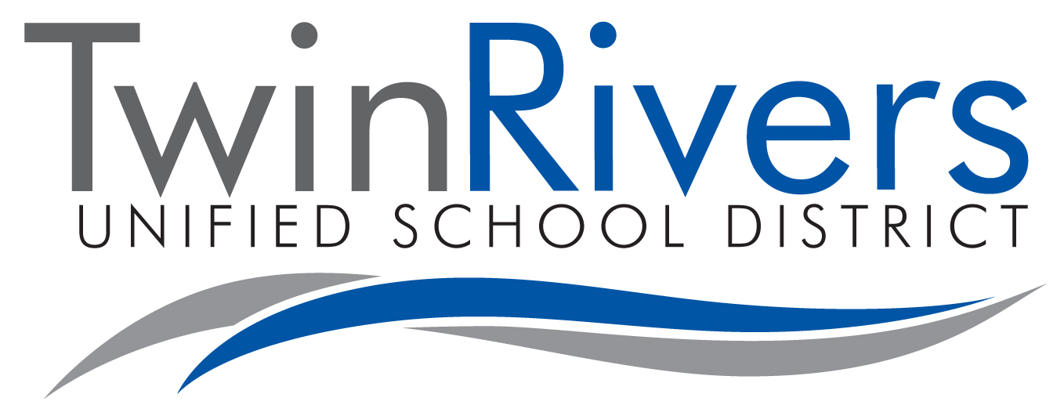

Dental Health Record

SITE: ◻ Morey ◻ Oakdale ◻ Rio Linda ◻ Village

Child’s Name: ____________________________________ DOB:___________ Gender ◻ M ◻ F

Parent/Guardian Name: ______________________________________________ Phone: ________________________

Address: ___________________________________________________City: _____________________Zip: _________

I authorize professionally-qualified individuals to exchange information about my child. I understand that all information will be kept in a confidential file.

Parent/Guardian Signature: __________________________________________________ Date: ___________________

Please list recommended services in order on the table below and restoration(s) you performed:

Tooth #/Letter | Surfaces | Description of Services | Date of Service
Missing Decayed Filled

In diagram above, indicate the following oral conditions before treatment:

Cleaning and fluoride treatment date completed: _______________

CHILD ORAL HEALTH SUMMARY

Dental Needs: Problems Noted:

 Routine recall visits  Special home emphasis, oral hygiene  Dietary  Harmful oral habits

 Developmental  Other___________
All planned treatment:

 Is complete

 Is not complete. Please check one or more:  Treatment (restoration, pulp therapy, extraction)  X-rays

 Cleaning  Fluoride  Other ______________________________________

Dentist: _____________________________________________ Signature: ____________________________________

Date: _________________ Phone: _______________________ Address: ____________________________________

Please return completed form to parent/guardian or FAX to 916-566-3486.

(Rev. 02/20)

